Contents

Link DRIVE: 7

**LINK NGHE Ở TRANG CUỐI CÙNG**

**Questions 1 -10**  
Complete the notes below.  
Write **NO MORE THAN TWO WORDS AND/OR A NUMBER** for each answer.

**The International School, Dubai**

**General Information and facilities**

* Two departments: Lower school, Middle school
* Location of school opposite the **1** ................
* School address: Meadows Drive. Dubai
* Uniform: a **2** .................. shirt, black trousers or shorts
* Lessons from 7.20 until **3**........................., Sunday - Thursday
* Children on Early Start programme are given **4**................................ before school starts
* Late Stay activities: playtime, help with homework, current term's spoil activity is **5** ................
* Music: **6**.........................lessons held on Tuesdays
* Languages: **7** ......................... from age 7

**Meeting with Head Teacher**

* Name of Head Teacher: Elizabeth Rose Day: **8**.................
* Time: **9** .................
* Can talk to the **10**........................ teacher in coffee break

**Questions 11-12**

**Choose TWO letters, A-E.  
*Which TWO things will employees need to do during their first week in their new office space?***

A. find out about safety procedures  
B. collect a new form of identification  
C. move boxes containing documents  
D. make a note of any problem that occurs  
E. learn about new company technology

**Questions 13-14**

**Choose TWO letters, A-E.  
*Which TWO steps have the company taken to improve the physical environment of employees' offices?***

A. provided comfortable seating  
B. installed a new heating system  
C. used attractive materials  
D. enlarged people's working space  
E. replaced the old type of lights

**Questions 15-20  
Label the plan below.  
Write the correct letter, A-I, next to Questions 15-20.**

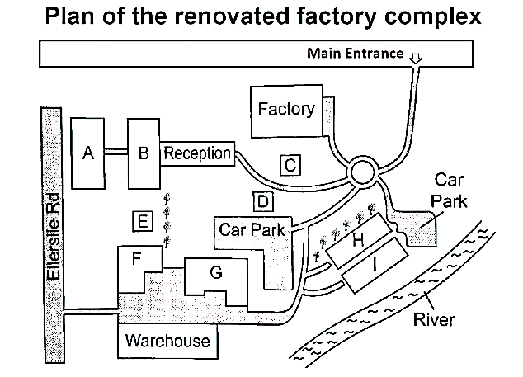

**15. Conference center...............**

**16. New office space...............**

**17. Stores...............**

**18. Finance...............**

**19. Café...............**

**20. IT Department...............**

**Questions 21–30**

**Questions 21 and 22**  
Choose TWO letters. A-E.  
Which are the **TWO** ***main duties for Personal Support Workers (PSWs)?***

A) talking with clients  
B) helping clients to eat and drink  
C) helping with physical needs  
D) ensuring clients are well and safe  
E) managing clients' pills

**Questions 23 and 24**  
Choose TWO letters, A-E.  
Which are the **TWO** ***requirements to do the PSW programme?***

A) high school completion  
B) a maths course  
C) a language qualification  
D) a clear driving record  
E) First Aid training

Questions 25-30  
**What topic do students learn about in each of the following courses?**  
Choose SIX answers from the box and write the correct letter, A-G, next to questions 25-30.

| **Topics:** A) independent living B) the ageing process stages C) PSWs’ role in health care D) workplace communication E) memory stimulation activities F) handling stress G) biological systems | **Courses:** 25) Understanding is Essential 26) Foundations 27) The Way We Work 28) Residence Care 29) Dynamics 30) The Power Within |
| --- | --- |

**Questions 31–40**

Complete the notes below.  
Write **ONE WORD ONLY** for each answer.

**Underwater Archaeological Sites**

**General Information**

* The Maoris are an example of a society that never developed a **31** .......................... form of communication.
* Discoveries at underwater sites have helped scholars better understand the everyday **32**........................... of ancient communities.

**Shipwrecks**

* In recent excavations, experts have applied advanced **33**.............................. to improve the accuracy of findings.
* One commonly identified cause of many wrecks is damage caused by a violent **34**.............................

**Learn from it:**

* Some findings have been used to produce a **35**................................. gallery to showcase life on board sunken vessels.
* Due to difficult access and preservation issues, the amount of **36**................................ conducted was quite restricted.

**Examples**

* There was one wreck where the crew used a **37**................................... as a defense against pirate attacks.
* Among the materials found was a **38**....................................... that detailed the ship’s intended route.
* Valuable cargo, especially items like **39**................................ , was a major motivation for early explorers.
* Various luxury goods were discovered, including jewellery and old **40**................................

# Link DRIVE:

<https://drive.google.com/drive/folders/1rvS9kd2LbUtilNRf2jkfazDxgTtsG1IX?usp=sharing>